**Static Measurements of the**

**Mechanical Properties of Rocks**

Geophysics 457

Safian Omar Qureshi

Kenneth Olusola Adebayo

ID 10086638

**Purpose:**

The purpose of this is to determine the Young Modulus, Poisson’s ratio, other elastic moduli. We also found seismic velocities from stress-strain measurements on a rock sample.

**Materials:**

-Paskapoo, Belly River and Limestone Samples

-Mass scale

-Calipers

-Hydraulic pressure press

-Logging software

**Theory:**

We can exert an axial force on a cylindrical core by using a rock press. The axial and radial strains, εz and εr will vary respective of the axial stress, σz. We can then measure the compression of the unit which will help us calculate other relevant properties of the rocks.

**Relevant Formulae:**





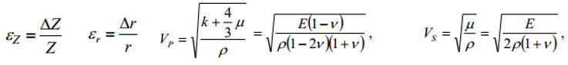

**Procedure:**

*Refer to lab manual

**Analysis:**

**Dimensions/Mass of Samples**

|  |  |  |  |
| --- | --- | --- | --- |
|  | Paskapoo | Belly River | Limestone |
| Diameter (mm) | 49.56 | 49.52 | 50.36 |
| Height (mm) | 139.58 | 140.1 | 139.7 |
| Mass (g) | 689.8 | 709.15 | 818.2 |

**Sample Calculations for the Parameters of Belly River:**

E = 6.324 E9 MPa v = 0.3994 (found from slope of σz vs εz and εr vs εz respectively)

$$p=\frac{mass}{volume} p=\frac{0.70915kg}{\left(pi*0.02476m^2*0.1401m\right)} p=2628 kg/m^3$$

$$k=\frac{E}{3-2v} k=\frac{6.324 E9 MPa}{3-2\left(0.3994\right)} k=2873 MPa$$

$$µ=\frac{E}{2\left(1+v\right)} µ=\frac{6.324 E9MPa}{2\left(1+0.3994\right)} µ=2260 MPa$$

$$λ=k-\frac{2}{3} µ λ=2.873 E9 MPa-\frac{2}{3}2260 E9 MPa λ=1366 MPa$$

$$Vp= \sqrt{\frac{k+\frac{4}{3}µ}{p}} Vp= \sqrt{\frac{2873 E9 MPa+\frac{4}{3}2260 E9 MPa}{2628kg/m^3}} Vp=1496.6m/s$$

$Vs=\sqrt{\frac{µ}{p}} Vs= \sqrt{\frac{2.260 E9 MPa}{2628kg/m^3}} Vs=927m/s$

**Compiling Relevant Moduli For All Samples**

|  |  |  |  |  |  |  |  |  |
| --- | --- | --- | --- | --- | --- | --- | --- | --- |
|  | E (N/m2) | v | P (kg/m^3) | k  (MPa) | µ  (MPa) | λ  (MPa) | Vp  (m/s) | Vs  (m/s) |
| Paskapoo  Sandstone | 6.113  E9 | 2.2492 | 2562 | 4080 | 940.7 | 3453 | 1443 | 606 |
| Bellyriver  Sandstone | 6.324 E9 | 0.3994 | 2628 | 2873 | 2260 | 1366 | 1497 | 927 |
| Rundle  Limestone | 7643  E9 | 0.515 | 2940 | 3880 | 2522 | 2199 | 1570 | 926 |

**Discussion:**

5)

1. One of the differences in the cycles was just how the cylindrical core sample behaves. During the compression cycle, it’s being subjected to the stress for the ‘first’ time. It is being forcefully ‘deformed’ during that cycle. Comparing to the depression cycle, we let off the stress and slowly let out the pressure. In this cycle, the rock is going back to its natural dimensions so it might behave differently than when it is unnaturally being compressed
2. The nonlinearity property of the slope can essentially help us to find the samples elastic limits. If it were simply linear, the rock would just compress at a constant rate, for an indefinite period. By being nonlinear, we can see under what pressure does the rock need more pressure to get it to have the same change as it did before. We can also find breaking/fracture points and this leads us to finding the parameters/moduli that we calculated.
3. Some of the errors that are caused when calculating the slope is accounting for the two cycles. Since each cycle isn’t completely perfect and the rock is under different types of stress (being compressed vs depressed), it results in slight errors when calculating the axial values length and radius. Being having slight errors in these, this will result in errors on the graph, which results in errors in the slope. Since a lot of the other moduli are dependent on the slope values, the error in the slope will thus cause errors in the other moduli themselves.
4. Since our reading completely perfect it is hard to draw conclusions and trends. However, change in the rock properties will obviously result in change in Young’s modulus, bulk modulus, and shear modulus will change seismic wave speed of the rock. In our case, the limestone had the highest Vp velocity. This might be because it was the densest. It also had the highest E value, the slope which has correlation with other parameters. In the unsaturated rock samples the density and the bulk modulus changes because air filled pores become filled with water. Water is difficult to compress than air, so the P wave velocity is high when compared to S wave velocity. This phenomenon can be seen in all rock samples where the P wave velocity is higher than S wave velocity. And comparatively between

6) **Error Discussion:** One type of error encountered in the lab is instrumental errors. Instrumental errors are simply the ‘physical’ limits of our scales such as the calipers and mass scale that have inherent inaccuracy in reading the last decimal place. These errors can’t really be corrected. Also like mentioned above, there were errors in the slope, which resulted in errors for other parameters we calculated.

Another type of error that can be accounted and corrected are human errors. Some of the errors we may have made was upsetting the sensitive displacement sensors. Since the displacement sensors are extremely sensitive, when switching out samples, they may not have been in the exact same position as they were in the previous samples so that may have caused some discrepancies. Another error would be human error when we didn’t exactly consistently measure it at exact increments of 50lbs.

For the last sample there was actually quite a bit of a problem. In the middle of doing the run, we had to lift the glass and adjust the sensor and this may have caused us quite a bit of error since they are really sensitive. The way we can correct these types of errors is simply being more prepared and careful when performing the lab.

7)

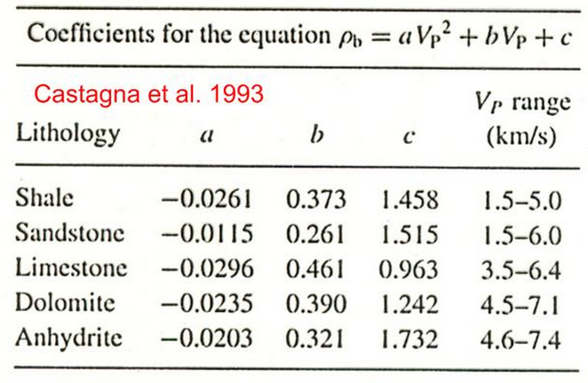

According to the literature, sandstone values should be between 1.5km/s, which is 1500m/s. These are comparable to what we got, which was 1443m/s and 1497m/s for the two sandstones.

We can use the 2.04 ratio to get the literature values of Vs, which is 735m/s for 1500m/s Vp. Our Paskapoo sample is somewhat close to this, being 606m/s while Bellyriver is far off at 927m/s. I couldn’t find a literature value for Vs for limestone because no ratio for that was given in the text.